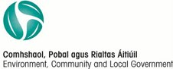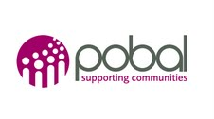

GALWAY RURAL DEVELOPMENT COMPANY LTD.

Registration Form for 2013 Short Course in Community Development

Surname

First Name(s)

Address for Correspondence

Telephone Evening/ Mobile

E-Mail Date of Birth

Voluntary/ Community Participation
Are you currently involved in any voluntary or community organisation, or have been in the past?
Name of Group

Signature: ____________________________ Date: ____________________
(Please also sign Data Protection below)

Galway Rural Development Company is registered with the Data Protection Commissioner under the Data Protection Act.
The information contained in this application form is for use by Galway Rural Development to determine to whom, and towards what end its funding will be distributed. The information may also be made available to the EU, Department of Environment Community and Local Government and Pobal as funders of the Programmes of Galway Rural Development.

I hereby consent to the use and disclosure of data and information contained in the application form.

Applicant Signature: _____________________ Date: ________________

